Customized Diet Program

Whether it's your bodyweight or it is the weight of procrastination, inconsistency, low motivation levels, work-life imbalance, judgments or simply not knowing where to start. This program will help you not just in losing weight but also in dropping the burden of achieving that weight loss. Don't let this extra weight pull you back. Go chase your goals and dreams.

Rs. 2500/- 3999 4 WEEK

Rs. 4900/- 7900 8 WEEK
Rs. 6500/- 11900 12 WEEK

Rs. 9900/- 23900 24 WEEK

Rs. 19900/- 47800 48 WEEK

Key points

- Dedicated Nutritionist
- Personalized diet plan every week (7 days plan, no repetition)
- Simple Diet Plan (with quantities, calories and nutritional details)
- Customization for Medical conditions (like PCOD, Diabetes, Thyroid, BP, Pregnancy,
Stress, Kidney, Liver disorders etc)
- Video consultation call with coach every week
- Weekly Counselling Call (In-depth analysis, motivation and Q&A)
- Consultation Notes after every call
- Dedicated chat support with your coach for 9 hours (Mon to Sat)
- 28 days Grocery plan
- Option to choose workout plans (Home or yoga)
* Special meal planning for travel, holidays, festivals, weddings etc.
- Weekly fun activities for Motivation
- Powerful affirmations to help you manifest your fitness goals
- Lifetime access to the Premium Community

Customized Child Nutrition Program

Healthy Growth Starts with the Right Nutrition

Every child is unique, and so are their nutritional needs. Our customized child nutrition program is designed to support healthy growth, improve immunity, build healthy eating habits, and address concerns like underweight, overweight, picky eating, low immunity, and nutritional deficiencies.

Why Choose This Plan?
Personalized diet plan based on your child's age, height, weight & health goals.
Easy-to-follow, home-cooked meal plans.
Regular progress monitoring & plan modifications.
Expert guidance by a Certified Clinical & Child Nutritionist.
Focus on long-term healthy eating habits, not temporary diets.

Rs. 1500/- 2000 4 WEEK

Rs. 2800/- 4000 8 WEEK
Rs. 3900/- 6000 12 WEEK

Rs. 6900/- 12000 24 WEEK

Rs. 1900/- 24000 48 WEEK

What's Included
✅ Personalized Child Diet Plan
✅ Weekly Progress Review
✅ Diet Plan Modifications
✅ Growth & Weight Monitoring
✅ Healthy Snack Recommendations
✅ School Tiffin Meal Ideas
✅ Parent Nutrition Guidance
✅ WhatsApp Support
✅ Lifestyle & Hydration Guidance
✅ Sustainable Healthy Eating Habits
Best For
Underweight Children
Overweight & Childhood Obesity
Picky Eaters
Low Immunity
Poor Appetite
Frequent Illness
Nutritional Deficiencies
Healthy Growth & Development

Reviews

FAQ

Q1) What kind of food will be given in the meal plan? +

Our diet plans include basic home-based food. No fat cutter drinks or fad supplements.

Q2) How frequently will my diet change? +
A new diet will be given every week. A Diet chart will be created on the basis of careful review of the previous week’s progress

Q3) I have tried a lot of diet programs in past but nothing worked or gained back the weight. How is your program any different? +

We believe in sustainability and hence through this program, we work on your eating patterns and lifestyle. The meals provided promote home-cooked Indian food items. We educate our clients to understand their body's requirements and enable them to understand their own body and its requirements. Getting fitter, feeling transformed, and believing that I'MWOW is what we truly stand for.

Q4) How much weight can I lose in one month? +

There is no fixed answer to this question. It depends on your current weight and how precisely you follow the given plans. On an average people who enrol with us lose upto 5kg in a month.

Q5) How soon will I see results? +

Just as eating wrong has an immediate effect on the body, so does eating correct. It might not be a measurable effect but you will start feeling better, more energetic and shrunk within a week or two of following the diet and exercising. Weight loss or rather fat loss, is a by-product. If you follow the plan, results will follow you back .

Q6) What kind of exercise is recommended? +

Any form of exercise like strength training, HIIT , running , yoga etc. which is challenging and enjoyable for you is recommended. There is no definite answer to these questions. Everybody is different and so are its needs.

Yoga & Beyond - Group Sessions
Transform Your Health Through Traditional Yoga

Experience expert-guided online yoga sessions designed to improve flexibility, strength, posture, mobility, and overall well-being. Whether you're a beginner or an experienced practitioner, our certified yoga trainers will help you achieve your health goals with a structured and personalized approach.

Why Choose Our Yoga Program?

Live interactive online classes

Certified Yoga Trainer guidance

Beginner to advanced level sessions

Safe and progressive practice

Personalized modifications for individual needs

Suitable for weight loss, back pain, flexibility, stress management, PCOD, thyroid, and overall fitness

Live Group Yoga Program

Duration Original Price Offer Price

4 Weeks ₹1,999 ₹999
8 Weeks ₹3,999 ₹1,799
12 Weeks ₹5,999 ₹2,499
24 Weeks ₹11,999 ₹4,499
48 Weeks ₹23,999 ₹7,999

Key points

✅ Live Group Yoga Sessions (Monday–Friday)

✅ Certified Yoga Trainer

✅ Beginner-Friendly Classes

✅ Strength, Mobility & Flexibility Training

✅ Breathing Practices (Pranayama)

✅ Meditation & Relaxation

✅ Posture Correction

✅ Progress Tracking

✅ WhatsApp Support

✅ Session Recordings (if available)

Customized Yoga Program with Live 1:1 Sessions

Weight loss or Healthy weight loss. Just losing weight should not be the goal. But, eliminating the root cause of unwanted fat and repairing the entire machine called body is the right way. Join this program if you want to lose weight happily and sustain it, where we provide you the right workout and amazing non-repetitive yoga sessions to lose that unwanted weight with bonus of improved nervous system, gut and mental health. 1:1 Personal Yoga Program

Duration Original Price Offer Price

4 Weeks ₹4,999 ₹2,999
8 Weeks ₹9,999 ₹5,499
12 Weeks ₹14,999 ₹7,999
24 Weeks ₹29,999 ₹14,999
48 Weeks ₹59,999 ₹27,999

Key Points

✅ One-on-One Live Yoga Sessions with 1Stepmore Yoga Coach

✅ Personalized Yoga Plan

✅ Flexible Session Timing

✅ Weekly Progress Assessment

✅ Customized Practice for Your Health Goals

✅ Pranayama & Meditation

✅ Lifestyle Guidance

✅ WhatsApp Support

✅ Priority Trainer Assistance

✅ Technique & Alignment Correction

- Ashtanga , Hatha and Power Yoga Sessions

- Weight loss special workouts
- Access to 1Stepmore premium community

Ideal For

Weight Loss

Back & Neck Pain

PCOS/PCOD

Thyroid Disorders

Diabetes

Stress & Anxiety

Postnatal Recovery

Senior Citizens

Flexibility & Mobility

Overall Wellness

Customized Diet and Group Live Yoga Sessions

Eat Right. Move Better. Live Healthier.

Achieve your health goals with a complete wellness program that combines a personalized diet plan with live group yoga sessions. Get expert guidance, regular follow-ups, and a sustainable approach to healthy living.
Combo Pricing
Duration Original Price Offer Price
4 Weeks ₹4,499 ₹2,999
8 Weeks ₹8,899 ₹5,999
12 Weeks ₹12,499 ₹7,999
24 Weeks ₹21,899 ₹11,999
48 Weeks ₹43,899 ₹21,999

Key Points

✅ Customized Diet Plan
✅ Live Group Yoga Sessions (Mon–Fri)
✅ Weekly Diet Review
✅ Regular Diet Plan Modifications
✅ Pranayama & Meditation
✅ Mobility, Strength & Flexibility Training
✅ Healthy Lifestyle Coaching
✅ WhatsApp Support
✅ Guidance by Certified Nutritionist & Certified Yoga Trainer
Perfect For
Weight Loss
PCOS/PCOD
Thyroid
Diabetes
Fat Loss
Stress Management
Back Pain
Overall Fitness & Wellness

Reviews
SAME AS EACH PLAN

FAQ- IT WILL COME UNDER ALL PROGRAMS AND NOTHING WILL BE CHANGE.

Reviews

HOME PAGE WILL BE LOOK LIKE THIS

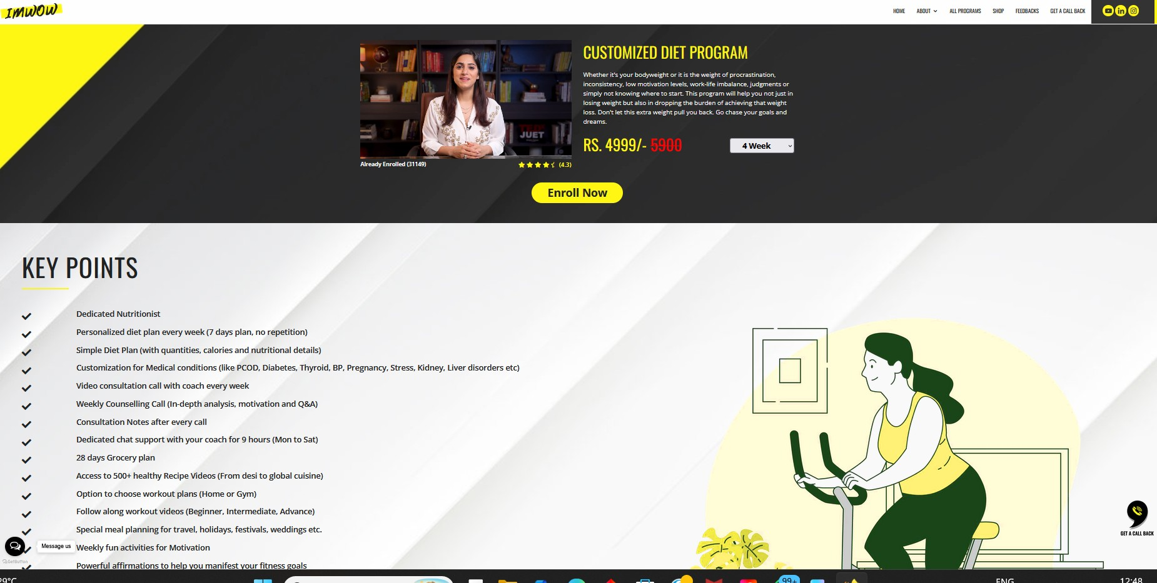

ALL PROGRAMM LOOKS LIKE THIS

